Training Project Report on

ROLE OF RAW MATERIALS QUALITY IN

INCREASING

BLAST FURNANCE PRODUCTION

Submitted in partial fulfilment of the requirement

of trainees for the award of the degree

Rashtriya Ispat Nigam Limited (RINL)  
Visakhapatnam Steel Plant

Pride of steel

Project Training Management System (PTMS)

RINL VSP

****National Institute of Technology Rourkela,

Odisha -769008

2025

# CERTIFICATE

This is to certify that the student of NATIONAL

INSTITUTE OF TECHNOLOGY ROURKELA is engaged in a project work titled

ROLE OF RAW MATERIALS QUALITY IN INCREASING BF PRODUCTION

submitted by-

WILLIAM KERY BUTTI (100042269)

MALLIPATI VARDHAN (100043733)

DUNGAVATH SATHISH NAIK (100043576)

In partial fulfilment of the degree of bachelors of

technology out in METALLURGICAL AND MATERIALS

ENGINEERING stream in,

NATIONAL INSTITUTE OF TECHNOLOGY ROURKELA is a record of bonafide work carried out by him under my guidance and supervision during the period from 12th may 2025 to 21st June 2025

Date:

Place: Visakhapatnam

Blast Furnace Department

RINL-VSP, VISHAKAPATNAM

RASHTRIYA ISPAT NIGAM

## LIMITED

VISAKHAPATANAM STEEL PLANT

A PROJECT REPORT SUBMITTED IN PARTIAL FULFILLMENT OF THE REQUIREMENT FOR THE AWARD OF

DEGREE OF BACHELOR OF TECHNOLOGY IN

METALLURGICAL AND MATERIALS ENGINEERING

Role of raw material quality in increasing BF production

|  |  |
| --- | --- |
| **Name** | **Trainee no** |
| WILLIAM KERY BUTTI | 100042269 |
| MALLIPATI VARDHAN | 100043733 |
| DUNGAVATH SATHISH NAIK | 100043576 |

Submitted by

ACKNOWLEDGEMENT

We are overwhelmed in all gratefulness and humbleness to acknowledge our deep and sincere gratitude to all those who helped me to shape this project.

It would have been impossible to achieve this project over a month without the backing of the elders and their guidance. We would be failing in my duty if we don't acknowledge their support throughout my continuous struggle, rise and fall to complete this project.

We express our grateful thanks to our guide, MR. SARAT and Mr. B SRINIVASA who helped us to complete the project with his continuous encouragement and involvement.

We are greatly indebted to express my deep sense of gratitude to who helped at his utmost in completing the project.

It gives us the immense pleasure to acknowledge our indebtedness to our operational guide, M GANESH BABU, AGM(Training) for his support throughout the course of the project.

We would also like to thank the Steel Plant for providing us with the Resources required in the course of this project.

Last but not least we thank BLAST FURNACE collective who have contributed their help in making the project.

### DECLARATION

We here by solemnly declare that the project report entitled ROLE OF RAW MATERIALS QUALITY IN INCREASING BLAST FURNACE PRODUCTION submitted by us is a bonafide work done and it is not submitted to any college. This Project work is in partial fulfilment of the requirement for the award of the B. Tech in Metallurgical Engineering from our respective college.

Place: VISAKHAPATNAM

Date:

#### ABSTRACT

In this project we have discussed about the role of raw material quality in increasing BF production. A blast furnace (BF) is a closed system into which iron-bearing materials (iron ore lump, sinter and/or pellets), fluxes (slag formers) and reducing agents (i.e. coke) are continuously fed from the top of the furnace shaft through a charging system which is bell less charging system. Abstract:

The efficient operation of blast furnaces is essential for the production of iron and steel, serving as a cornerstone of the metallurgical industry. The role of raw material quality in optimizing blast furnace performance and increasing production output cannot be overstated. This project report delves into the critical aspects of raw material quality and its profound impact on blast furnace operations. Through a comprehensive analysis, it explores the influence of chemical composition, physical properties, and sourcing methods on furnace productivity. The report also examines various strategies, including supplier selection, process optimization, and research and development initiatives, aimed at enhancing raw material quality and maximizing furnace efficiency. Drawing upon case studies, industry standards, and best practices, this report provides valuable insights into the pivotal role of raw material quality in driving continuous improvement and competitiveness in the steelmaking sector.

TABLE OF CONTENTS

1. An overview of V-S-P

* History and background of RINL
* Major sources of raw material
* Major departments
* Installed capacity
* Key achievements

1. Process flow chart of plant
2. Blast furnace
   * + - Burden handling and charging
       - Hot blast stoves
       - Furnaces
       - Cast house and slag granulation plant
       - Pig casting
       - Hot metal ladle repair shop
       - Masses and compound shop
       - Gas cleaning plant

1. Blast furnace productivity and efficiency

* Productivity
* Fundamentals of blast furnace productivity
* Factor affecting productivity of BF

1. Raw material in steel making

* List of raw materials
* Characteristics of ideal raw material
* Common source and procurement methods
* Quality parameters
* Sampling and testing procedure
* Strategies for Managing Variability in Raw Material Quality
* Importance of Quality Control in Blast Furnace Operations

1. Observations and results

* Mass balance
* Burden process volume
* Important data

1. Conclusions

### CHAPTER-I

### AN OVERVIEW OF VIZAG STEEL PLANT

Visakhapatnam Steel Plant, The First Coastal based steel plant of India is located 16km southwest of city of destiny i.e Visakhapatnam. Bestowed with modern Technology VSP has a installed capacity of 3 million tonnes per annum of Liquid steel and 2656 million tonnes of saleable Steel. At VSP there is emphasis of total automation, Seamless integration and efficient up gradation, which result in wide range of land and structural products to meet stringent demands of discovering customers within India and abroad VSP products meet exalting international quality standards such as JIS,DIN,BIS,BS etc.

VSP has become the first integrated steel plant in the country to be certified to all the three international standards for quality (ISO-9001), for Environment Management (ISO-14001) & for occupational Health and Safety (OHSAS-18001). The certificate covers quality systems of all operational, maintenance, service units besides purchase Systems, Training and Marketing functions spreading over 4 Regional Marketing officer 20 branch offices and 22 stock yards located over all over the country.

VSP by successfully installing of operating efficiency Rs.460Crores worth of pollution control and Environment control equipment's and converting the barren landscape by planting more than 3 million plants has made the steel plant, Steel Township and surrounding areas into a heaven of lush greenery. This has made steel plant township a greener, cleaner and cooler place, which can boast of 3 to 4 degree centigrade lesser temperature even in the peak summer compared to Visakhapatnam city.

VSP exports Quality Pig iron & steel products to Lanka, Myanmar, Nepal, Middle East, USA and south East Asia(pig iron). RINL-VSP was awarded "star Trading House" status during 1977-2000. Having establishment a fairly dependable export market, VSP plan to make a continuous presence In the export market. Having a total manpower of about 16,613 VSP has envisaged a labour productivity of 265 Tonnes per man-year of liquid steel, which is best in the country and comparable with the international levels.

1.1 BACKGROUND:-

With a view to give impetus to industrial growth and to meet inspirations of people from south India,

Government of India decided to establish integrated steel plants in public sector at Visakhapatnam (AP) and hotspot (Karnataka) besides a special steel plant Salem (Tamil Nadu). The announcement was made in parliament on 13th April 1970 by then prime minister of India late Smt. India Gandhi.

A site was selected near Balcheruvu creak near Visakhapatnam city by committee set up for purpose, keeping in the view topographical features, greater availability of land and proximity to a future port. Smt. Gandhi laid the foundation stone for the plant on 20-01-1971.

The construction of plant started on 1 st February 1982. Government of India on 18th February 82 formed a new company called Rastriya Ispat Nigam Limited and transferred the responsibility of constructing, commissioning of operating the plant at Visakhapatnam from Steel authority of India LTD to RINL. Due to poor resource availability, the construction could not keep pace with the plans, which lead to appreciable revision of plant coast. In view of the critical fund situation and need to check further increase in the plant costs.

The availability of resources were continued to be lower than what was planned and this further delayed the completion of construction of the plant finally all the units were constructed and commissioned by july'92 at a cost of 8529crores. The plant was dedicated to nation by the then prime minister of India late Sri P.V. Narasimha Rao.

Since commissioning VSP has already crossed many milestones in the fields of production,

Productivity & Stones in the fields of production, productivity & exports. Coke rate of the order of 509 kg/Ton of Hot metal, average converter life of 2864 heats an average of 23.6 heats per sequence in continuous Bloom caster. Specific energy consumption of 6.07 G. kcal/ton of liquid steel a specific refractory consumption of 8.94 kg and a productivity of 265 Ton/man year are some of the peaks achieved (during the year 2004-05) in pursuit of excellence.

1.2 VSP TECHNOLOGY: State-of-The-Art

* 7 meter tall coke oven Batteries with coke dry quenching.
* Biggest Blast furnace in the country.
* Bell less top charging system in Blast furnace (BF).
* 100% slag granulation at BF cast house.
* Suppressed combustion LD gas recovery system.
* 100% continuous casting of liquid steel.
* "Temp core" and "stelmor" cooling process in LMMM & WRM respectively.
* Extensive was to heat recovery systems.
* Comprehensive pollution control measures.
  1. Major sources of Raw materials:

The below table shows the major sources of raw materials.

Table-1.1 MAJOR SOURCES OF RAW MATERIALS

|  |  |
| --- | --- |
| RAW MATERIALS | SOURCES |
| Iron ore lumps and fines | Bailadilla, Madhya Pradesh |
| BF Limestone | Jaggayapeta, Andhra Pradesh |
| SMS Lime stone | UAE |
| BF Dolomite | Madharam, Andhra Pradesh |
| SMS Dolomite | Madharam, Andhra Pradesh |
| Manganese ore | Chipurupalli, Andhra Pradesh |
| Boiler coal | Talcher, Orissa |
| Coking coal | Australia |
| Medium Coking Coal (MCC) | Gidi/swang/Rajarappa/KasgaIi |

Water Supply:

Operational water requirement of 36Mgd is being net from the yeleru water supply scheme.

Power Supply:

Operational Power Requirement of 180 to 200 MW is being net through captive Power Plant is 286.5

MW. VSP is exporting 60MW Power to APSED.

* 1. Major departments :

The below table shows the major units

TABLE-1.2 MAJOR UNITS OF VSP

|  |  |  |
| --- | --- | --- |
| Department | Annual capacity | UNITS(3.O MT STAGE) |
| Coke ovens | 2,261 | 4 Batteries of 67 ovens and 7 meters height |
| Sinter Plant | 5,256 | 3 Sinter Machines of 312 sq.mtrs Grate area each |
| Blast furnace | 3,400 | 3 Furnaces of 3820 cubic meter volume each |
| Steel melt shop | 3,000 | 3 LD Converters each of 133 cubic meters volume and six4 strand bloom casters |
| LMMM | 710 | 4 Strand Finishing Mill |
| WRM | 850 | 2* 10 Strand Finishing  Mill |
| MMSM | 850 | 6 Strand Finishing Mill |

MAIN PRODUCTS OF VSP:

The below table shows the main products of VSP

TABLE-1.3 MAIN PRODUCTS OF VSP

|  |  |
| --- | --- |
| STEEL PRODUCTS | BY PRODUCTS |
| Angles | Nut Coke Granulated Slag |
| Billets | Coal dust line fines |
| Channels | Coal Tar Ammonium Sulphate |
| Beams | Anthracene oil |
| Squares | HP Napthalene |
| Flats | Benzene |
| Rounds | Toulene |
| Re-bars | Zylene |
| Wire rods | Wash oil |

* 1. MAJOR DEPARTMENTS OF VSP:

The Major Departments of VSP are enlisted as below.

1. Raw Material Handling plant (RMHP)
2. Coke ovens & Coal chemical plant (Co & CCP)
3. Sinter Plant (SP)
4. Blast furnace (BF)
5. Steel Melting Shop (SMS)
   * + Converter
     + Continuous casting department
6. Rolling Mills
   * + - Light & Medium Merchant Mill (LMMM)
       - Wire rod Mill (WRM)
       - Medium Merchant & Structural Mill (MMSM)

1.7 AUXILIARY (Facilities) Departments:

1. Power generation & Distribution
2. Water Management (WMD)
3. Traffic Department
4. Engineering Shops & Foundry (ES & F)
5. Utilities Department
6. Quality Assurance and technology development
7. Calcining and Refractory Material Plant (CRMP)
8. Roll Shop & Repair shop (RS & RS)
9. Field machinery department (FMD)
10. Power Engineering Maintenance (PEM)
11. Plant Design (PD)

12.1nstrumental Department

13.Electrical Repair shop (ERP)

14. Electro Technical Laboratory (ETL)

15.Central maintenance Mechanical Department

16.Central Maintenance Electrical Department

17.Steel Town Ship

1.8 RAW MATERIAL HANDLING EQUIPMENT:

VSP annually requires quality raw materials viz. iron ore, fluxes (limestone, dolomite) coking and noncoking coals etc; for producing 3 million tonnes of liquid steel. To handle such a volume of incoming raw materials received and to ensure timely support of consistent quality of feed materials to different VSP consumers, Raw materials handling plant serves a vital function. The unit is provided with elaborate unloading, blending, stacking & reclaiming facilities.

1.9 COKE OVENS & COAL CHEMICAL PLANT:

Blast furnaces, the mother units of any steel plant requires huge quantities of strong, hard and porous solid free in the form of hard metallurgical coke for supplying necessary heat for carrying out the reduction and refining reaction besides acting as a reducing agent.

Coke is manufactured by heating crushed coking coal in the absence of air at temperature of 1000 0 C and above for about 16 to 18 hours. A Coke oven comprises of 2 hallow chambers namely coal chamber and heating chamber. In heating chamber a gaseous fell is burnt and heated so generated carbonize the coking coal placed in the adjacent coal chamber the coal chemicals such as benzoic, tar etc are extracted in coal chemical plant from coke oven gas.

1.10 SINTER PLANT:

Sinter is a hard and porous ferrous material obtained by agglomeration of iron ore fines, coke breeze, lime stone fines, metallurgical wastes etc; sinter is a better feed material to blast furnace and help in increasing productivity, decreasing the coke rate & improving the quality of hot metal produced.

Sintering is done in sintering machines by heating prepared feed on a continuous metallic belt made of pellets at 1200-1300 0 C. Hot sinter discharged from sintering machines is crushed and cooled before dispatching to blast furnaces.

1.11 BLAST FURNACES (BF):

Hot metal is produced in blast furnaces, which are tall vertical furnaces. The furnace is named as blast furnace as it is run without high pressure & temperature Raw materials such as sinter/iron ore lumps, fluxes and coke are charged from top and hot blast at 1100-1300 0 C and 5.75 KSCG pressure is blown almost from the bottom. The furnaces is designed for 80% sinter in the burden.

1.12 STEEL MELT SHOP:

Steel is an alloy with iron and carbon upto 1.8%. Hot metals produced iron blast furnace contains impurities such as carbon (3.5-4.5%), Silicon (0.4-0.5%), Manganese (0.3-0.4%), Sulphur (0.045% max) and Phosphorous (0.14% max) is not suitable as common engineering materials. At steel melting

shop, the impurities are eliminated or decreased by oxidation process to improve the quality in LD converts.

1.13 CONTINUOUS CASTING DEPARTMENT:

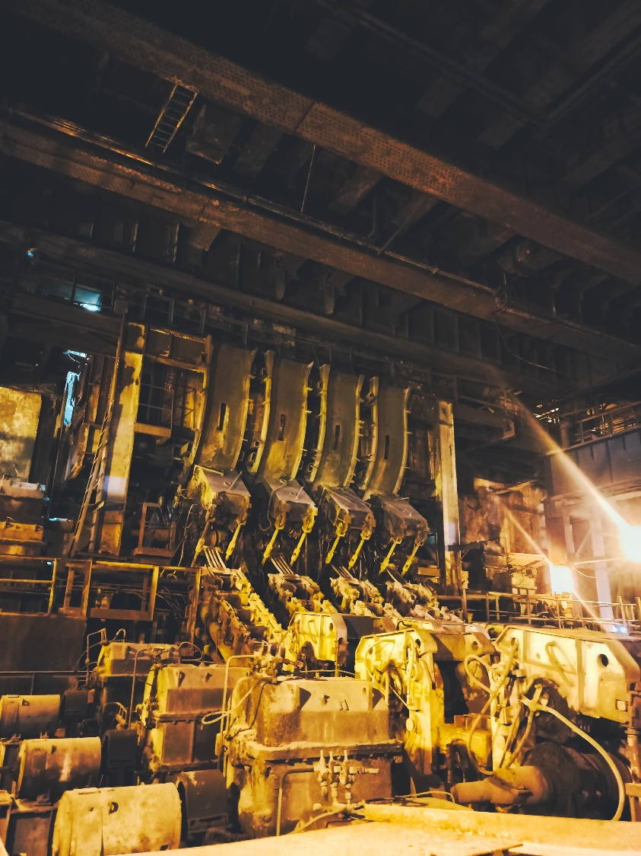

Continuous casting may be defined as temping of liquid steel in a mould with a false bottom through which partially solidified ingot/bar similar to the shape & cross section of the mould is continuously withdrawn at the same rate at which liquid steel is teamed in the mould.

Facilities at CCD include a lift and turn table for ladles, copper mould, oscillating system tundish, primary & secondary cooling arrangement to cool the steel bloom, Gas cutting machines for cutting machines for cutting blooms in required lengths.

1.14 ROLLING MILLS:

Blooms produced in SMS-CCD do not find much applications as such are required to be shaped into products such as billets, rounds, squares, angles etc by rolling them in sophisticated high capacity, high speed, fully automated rolling mills, namely.

* 1. Light & Medium merchant mills (LMMM)
  2. Wire Rod Mill (WRM)
  3. Medium Merchant and structural mill (MMSM) 1.15 CONVERTER DEPARTMENT:



Fig. 1.1: Hot metal poured in to the converter vessel

VSP produces steel employing 3 numbers of top blown oxygen converters called LD converters (L & D stand for "Lintz" and "Donawitz"- the two towns in Austria where this process was first adopted) or basic oxygen furnaces/converters. Each converter is having 133Cu.M volumes capable of producing 3 million tonnes of liquid steel annually. Besides Hot metal, steel scrap, fluxes such as calcined or dolomite form part of the charge to the converters 99.5% pure oxygen at 15-16 KSCG pressure is blown in the converter through oxygen lance having convergent and divergent copper nozzles at the blowing end. Oxygen oxidises the impurities present in the hot metal, which are fixed as slag with basic fluxes such as lime during the process heat is generated by exothermic reaction of oxidation of metalloids viz. si, mn, p and carbon and temperature rises to 1700 0 C enabling refining & slag

formation.

Different grades of steel of superior quality can be made by this process by controlling the oxygen blow or addition of various ferro alloys or special additives such Fe-Si, Fe-Mn, Si-Mn, Coke breeze, Aluminium etc; in required quantities while liquid steel is being tapped from the converter into a steel ladle. Converter/LD gas produced as by product is used as secondary fuel.

1.16 CHARACTERISTICS OF VSP CONVERTERS:

The below table shows the characteristics of VSP converters

TABLE-1.4 CHARACTERISTICS OF CONVERTERS

|  |  |
| --- | --- |
| Capacity | 150 Tonnes per heat/blow |
| Volume | 133 Cu.meters |
| Converter Sp. Volume | 0.886 Cu. Mt per tonne |
| Tap to Tap time | 45 minutes- 60 minutes |
| Height to Diameter ratio | 1.36 |

LINING:

The below table shows the characteristics of converter lining

TABLE-1.5 LINING OF CONVERTERS

|  |  |
| --- | --- |
| Working | Tar Dolomite bricks |
| Permanent | Chrome Magnetite bricks |
| Average Lining life | 649(1999-2000 hours) |

Liquid steel produced in LD converters is solidified in the form of blooms in continuous blooms casters. However to homogenize the steel and to raise its temperature, if needed, steel is first routed through argon rinsing action, IRUT (injection Refining & Up temperatures) ladle furnaces.

One of the key achievements of vsp Is producing over 100 million tons of saleable steel products since its inception in November 1990.

2) process flow chart

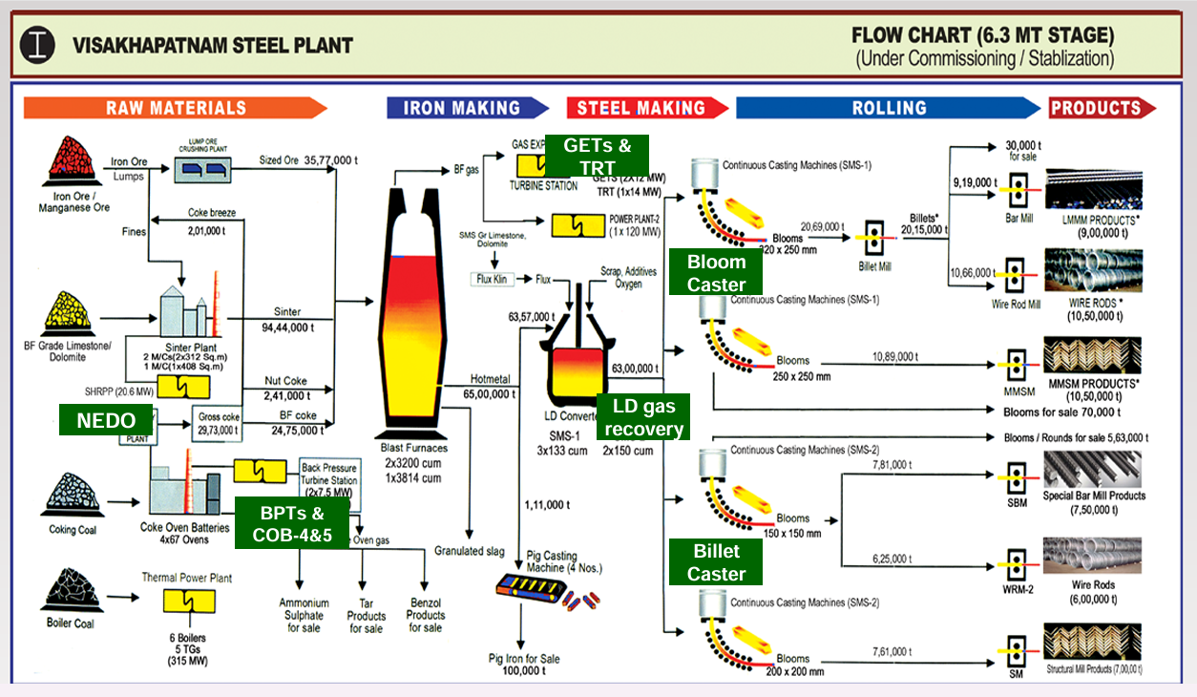

### **CHAPTER-3**

### BLAST FURNACE

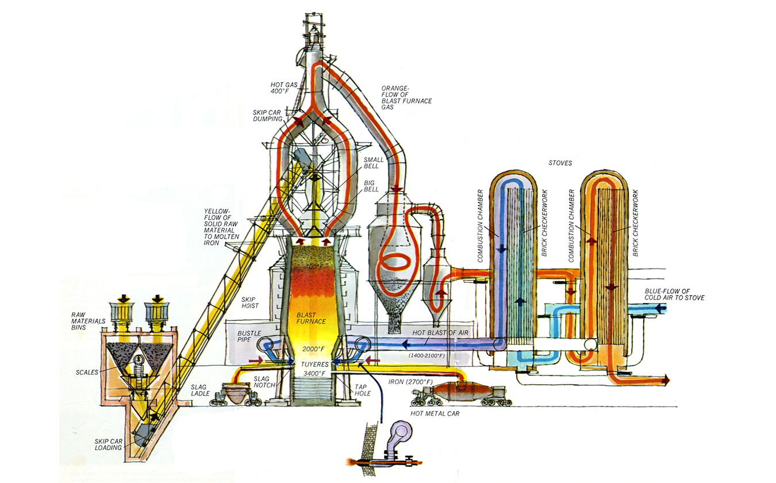

3.1 BURDEN HANDLING AND FURNACE CHARGING:

Burden materials are received in the stock houses, one for each furnace through a junction house. Coke is handled by two conveyors 1600mm width and 350TPH capacity, sinter, lump ore by two conveyors of 1400 iron width and 800TPH capacity, sized ores and additives will be handled by one reserve conveyor of 1500mm width and 800TPH.

Junction house has a cross over through rolling reversible conveyor and stationary resiprocating conveyor .For each furnace, there are five bins for coke,3bins for lump ore, 1 bin for nut coke,3 bins each for limestone/LD slag and quartzite/used silica bricks and manganese ore.

Coke, sinter and iron ore are screened in screens upto 400m3/hr capacity to remove the fines. The screened material is fed into the conveyor for burden handling to top through a horizontal conveyor. Conveyors for burden handling to top are 2000mm width 2160m3/hr capacity and are operated continuously. The materials are positioned in conveyor in separate batches at certain intervals and in a certain sequence as per present programme. PLC system is provided for batching, weighing and feeding of the burden to the furnace top.

The Paul wurth, bell loss top system is installed for furnace charging. The system consists of two bunkers of 47 cubic capacity meter each, charge moving hoppers rotating through. All drives are hydraulically operated except for trough rotation and tilting which are electrically operated. Semi clean BF gas and nitrogen are used for pressure equalisation in charging bunkers. Nitrogen is used for cooling rotating trough drive and for blowing off stock bin gates and sealing valves of charging arrangement. Mechanical gauge rods are provided for measuring stock level.

The burden handling system premises are hydraulically flushed 600m3/hr water. Total effluents generation is 600m3/hr. After primary settling, the water is pumped to sinter plant for further use.

3.2 HOT BLAST STOVES:

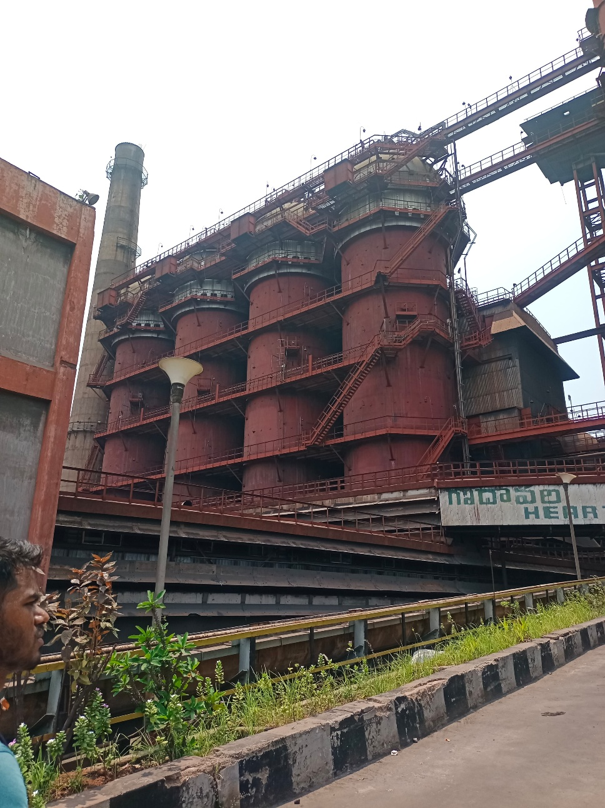

There are fur hot blast stoves for each furnace with a total heating surface of 224,000 m2. The dome can be heated to a temperature of 1450 0 C maximum while the waste flue temperature is upto 400 0 C.

The stoves are capable of giving a blast temperature upto 1300 0 C. stoves are heated by a mixture of blast furnace gas and coke oven gas having a calorific value of 1,100 kcal/ncum. Pressure of mixed gas before burners is 600mm W.C. gas mixing station is provided to mix bf gas, co gas in required proportion and to get the necessary calorific value. Separate stations are provided for each furnace.

High temperature zone is lined with silica and mullite corundum refractories, medium temperature zone, with kaoline refractories and low temperature zone with fire clay refractories. The shell of dome and cylindrical part is heat insulated with a heat proof gunnite concrete in high temperature zone. Gaps between shell and walls are filled with mats from fibrous materials. Checker-work is lined with hexahedral refractories with round cells of 41mm dia. Combustion chamber is inbuilt construction of elliptical shape. The chimney is of 80mts high, 3.5mtrs diameter at the mouth. It is of reinforced concrete and fire clay lined. Stack for back drought is made of metal with refractory lining. Air supply for burners is centralised. 3 fans of 120,000 m3/hr, 1080mm W.C capacity each are provided for the purposes.

Water cooling arrangements has been provided for cooling of hot blast valves and burner cut-off valves.

3.3 FURNACES:

Two blast furnaces of 3200 m3 useful volume, is capable of producing 1.7 MT of hot metal per year while operating for 350 days are installed.

The basic characteristics of furnace are:

* Useful height from iron notch from central line to rough bottom in vertical position 33,100mm.
* Height of hearth — 4600.
* Height of bosh — 3400mm.
* Height of belly— 1900mm.
* Height of shaft — 20,000mm.
* Height of top — 2300mm.
* Height of dead layer — 1203.5mm.
* Diameter of hearth — 12000mm.
* Diameter of belly — 13000mm.
* Diameter of top — 8900mm.
* Bosh
* Shaft angle — 83!43"22'
* No. of tuyeres — 32
* No. of tap holes —4
* No slag notches are provided.

The lower part of the hearth bottom is lined with graphitized carbon blocks while upper part is lined with high refractory mullite bricks in the center and with the carbon blocks in the periphery. Side walls of the hearth are lined with carbon blocks in lower part and alumino-silicate bricks are used for lining of bosh, belly and shaft. Furnace top is lined with non-cooled steel slabs of suspended construction, while non-cooled cast iron slabs are used for furnace dome. Peripheral cooling plates are used for cooling of upper parts of hearth bottom, hearth, tuyere zone, bosh, belly, and lower part of shaft. For middle part of shaft, peripheral plates with independently cooled projections are cooled. There are 664 cooling plates. Besides, there are 32 breast coolers, 32 tuyere coolers, 32 tuyeres, 8 nozzles in furnace dome. The water requirement for cooling is 5555m3/hr per furnace at 80mm wc.

The hot metal is discharged into 140T hot metal ladels by rocking runners in cast house. Hot metal ladel are moved by car pusher. At every notch a notch opener machine and an electric gun is provided. The cast house is circular in shape and 2 circular cranes 20/5+5 T and a circular platform 5mtrs width for maintainance and observation of tuyere shop is also provided.

There are 16 — 20 casts in a day. Cast house has a good aeration. Provision has been made for gas and dust exhaust from iron notches, skimmers, rocking runners, covers and from housing of the drum of the conveyor from burden handling to top. 4 mill fans of 160,000m3/hr capacity and 900kgf/cm2 pressure and two exhaust fans of 492,000m3/hr capacity and 430kgf/cm2 pressure are provided. Dry cleaning of the gas is carried out in electro-static precipitators, 2 horizontal type 3 fold precipitator having needle type discharge electrodes are provided. Dust is granulated and dispatched to sinter plant by dump track. Clean gas is fed to chimney of 5mtr dia, 100 mtr height. Dust content is reduced from 2.5 — 0.1gm/m3. About 60 tons of dust is collected daily from two precipitated. Furnace process control is computerised.

4 gas-off takes run vertically from furnace dome, which are connected to each other in pairs firstly forming 2 vertical off-takes and these 2 joining to form one central vertical take-off which is connected to a dust catcher of 12m dia through a down comer. Dust catcher and gas pipe lines are lined with fire clay bricks. Moistening and discharge of dust is carried out by a screw conveyor. The furnace can be separated from the dust catcher by 3000mm dia cut-off valve in upper part of dust catcher.

3.4 CAST HOUSE SLAG GRANULATION PLANT:

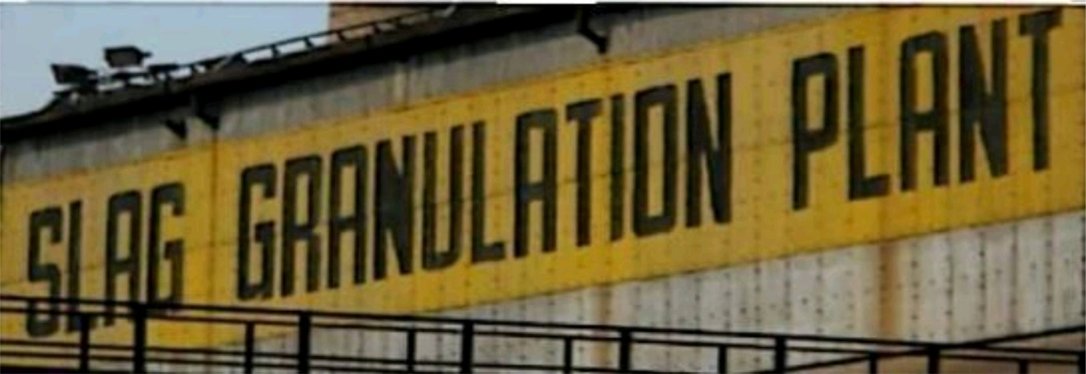

Fig. 2.1: Slag granulation plant

The molten slag produced by the furnaces is fed to cast house slag granulation plant to produce granulated slag. Two granulation plants are provided for each furnace adjoining the cast houses on two opposite sides.

Slag is discharged from the furnace 16 to 20 times a day, duration of each discharge being up to 60 minutes. Each granulation unit comprises two process lines (one stand by), designed to receive all slag through two iron notches. Each process line comprises of one granulator, one slag air lift, one receiving bin and water supply re-circulating system. Steam from receiving hopper is discharged to atmosphere through a chimney.

The granulated slay from the dehydrator is discharged into an intermediate hopper and from there it is fed to final storage through a conveyor system. The granulation of liquid slag is done by water jets and the granulation water is delivered by dredged pumps in a quantity of 2000 m3/hr at a minimum pressure of 5atg in the granulator. Temperature of pumped water is around 90 degrees C. with an average suspended matter content of upto 2 g/litre. Through put of makeup water is 300 m3 per granulation plant.

For air lifting thickened pulp from receiving bin to separator, compressed air is used. The plant is designed for a maximum slag discharge rate of 10T/min and hot metal content in the slag will be 12.7 kg/T.

The granulation plant works for 350 days in a year. The combined conveying system for handling granulated slag from both furnaces has a capacity of 600 TPH. Two conveyor systems one acting as standby is provided.

The storage is open dump type and we can hold about one month production. From the storage slag is loaded in railway wagons and in trucks by grab cranes.

3.5 PIG CASTING:

Four double strand pig casting machines of 1700 TPD capacity are installed to treat off grade metal and metal diverted due to stoppages in SMS. The machine can handle one furnace production. Each PCM is served by 75 T, overhead trolley to tilt the 140 T hot metal ladle. Pig weight is about 45kgs. Facilitates for lime washing of moulds and recirculating water system for cooling the pigs, including a settling tank, is provided.

The cold pig from machines are collected in wagons and sent to open gantry pig iron storage yard. The yard is of 300 *40m size and cold pigs are separated in lots according to grade. Two 150 T rail weight bridges are provided to weigh outgoing loaded wagons.

3.6 HOT METAL LADLE REPAIR SHOP:

The main objectives of this shop are as follows:

* To ensure placement of hot and clean metal ladles to each furnace in time for casting.
* To ensure quick despatch of hot metal loads to their planned destination and also ensure early withdrawal of empties from PCM/SMS in order to thoroughly clean the same before placement.  To effectively coordinate with rail traffic department/ 2BFs/SMS/PCS to ensure achieving of objectives.
* The entire shop working rotates around the three objectives. The main equipment/tools/ devices provided in the shop to achieve those objective are as below:
  + 1. 2Nos. of 120/50 tons capacity E.O.T cranes
    2. 30Nos. of conventional open top metal ladles and 7Nos. of torpedo ladles to hold and transfer liquid hot metal.
    3. 4Nos. of metal ladle pits with stands to hold conventional ladles during mechanical repair jobs/RED lining jobs.
    4. 2Nos. of drying installation to dry and preheat freshly lined conventional ladles before taking hot metal in them to avoid explosion and thermal shock.

3.7 BLAST FURNACE MASSES AND COMPOUND SHOP:

Refractory masses required in cast house viz., Runner mass, water mass mudgun mass, Tap hole frame mass are prepared in masses compound shop.

The raw materials required for preparing mass are received at various sizes from the different sources. These are crushed in various stages and stored in final storage bin. There are 12 final storage bins out of which 6 are used for coke, 2 for plastic fire clay, 2 for pitch and 2 for grog. The capacity of final storage bin is 30 cubic meters.

There are six operating groups for raw materials handling and preparation of masses.

GROUP 1: it is primary handling of coke breeze and plastic fire clay. In case of coke there will not be any crushing in this stage. If coke contains moisture more than 0.51 it is taken through rotary drier or otherwise drier is passed and coke is taken directly to intermediate bunker. In case of clay, the plastic clay of 250mm size is crushed in tooth roll crusher to 40mm size and if it contains moisture more than 3 it is taken through drier or otherwise drier is passed and the crushed clay is taken to intermediate bunker of 60 meter cube capacity.

GROUP2: In this group final crushing and storage of plastic clay is carried out. Clay from intermediate bunker is taken to disintegrator through a chute feeder where it is crushed to 0.5mm and is stored in the final storage bins with the help of belt bucket elevator and a screw feeder. The capacity of disintegrator is 5T/hr.

GROUP3: In this group crushing of coke breeze and storage of crushed coke on final bins is carried out. Coke breeze of 25 nun size from intermediate bunker is taken to four roll crusher via chute feeder where it is crushed to Imm and is stored in final storage bins.

GROUP4: in this group pitch and grog are crushed and stored in final storage bins. The material crushed in two stages. Pitch/grog of 250mm size is loaded in main bunker with the help of grab crane. The pitch/grog is fed to a jaw crusher through a reciprocating feeder and primary crushing takes place.

After primary crushing pitch is taken to two roll crusher where it is crushed to 3mm size and then it is stored in final storage bias.

GROUP5&6: In these groups mass is prepared with the raw materials stored in final storage bins. One a pan mixer is provided in each group. There are three weighing hoppers common for both the groups. Raw materials from the final storage bins in different proportions are weighed in weighing hoppers and then in through conveyors they are taken to pan mixers where water/oil is mixed and mass is prepared

These are two storage tanks (25 cubic meter capacity) for wash oil/L.C oil. All the groups can be operated through PLC and if required they can be operated in local mode.

There is a 5 ton capacity crane for handling the mass boxes.

3.8 GAS EXPANSION TURBINE STATION:

This is intended for generation of electric power utilising the potential energy of the compressed BF gas. One turbine is provided for each furnace. Each turbine operates the turbo generator of 12 MW nominal rating with exciter placed on one shaft with the turbo generators.

3.9 GAS CLEANING PLANT:

The rated dust content in gases after the dust catcher, when the blast furnace is operated at high top pressure 6.3gm3/normal cubic meter and at low top pressure upto 15gms/N cubic meter. Further cleaning upto 4 mg/N cubic meter is accomplished in wet gas cleaning plant, consisting of high pressure scrubber of 9000mm dia, two venturi pipes with adjustable drop of pressure by changing throat cross section, 2600 nun dia spray catcher and the cyclone spray catchers. A BF gas flare stack is provided for prevention of the excessive pressure in outdoor distributing BF gas pipe lines and centralised burning of the discharged temporary surpluses of BF gas.

3.10 AIR CONDITIONING STATION:

To supply air to all units, two central air conditioners 200,000 cubic meter per hour capacity are installed. In cold season one unit will be in operation. Air is subjected to cleaning cell filters, adiabatically cooled and humidified in the spray chambers in summer. Air at a temperature of 30 0 C and 90 S humidity is supplied through yard pipe lines. In cold season, air is subjected to only cooling. The total requirement is 392,000 normal cubic meter per hour.

3.11 CONVEYORS:

The details of conveyors in blast furnace as follows

Table no-2.1 DIMENTIONS AND QUALITY OF CONVEYOR

|  |  |  |
| --- | --- | --- |
| Width(mm) | Length(M) | Quantity |
| 1600 | 1542 | 12 |
| 1400 | 2250 | 18 |
| 1200 | 1138 | 4 |
| 1000 | 1800 | 10 |

#### **CHAPTER IV BF PRODUCTIVITY AND EFFICIENCY**

WHAT IS PRODUCTIVITY:

The effectiveness of productive effort, especially in industry, as measured in terms of the rate of output per unit of input. Productivity is a measure of how well resources are utilized to produce output.

Money (revenue or value added)

Product (quantity or value)

Service (quantity or value)

Amount or Quantity of output

Productivity =

RESOURCE INPUT

|  |
| --- |
| ManPower (man - hour)  Machinery (machine - hour)  Materials (materials - quantity)  Money (value of input) |

##### FUNDAMENTALS OF BLAST FURNACE PRODUCTIVITY

Producing more hot metal from a blast furnace involves the following:-

* Charging more raw materials
* Blowing more air through the tuyeres, more often than not, enriched with oxygen
* Tapping more hot metal and slag
* Handling increased amounts of top gas
* Maintaining stable operation of the furnace in terms of control over gas flow, and smooth burden descent
* Controlling lining wear in the stack, bosh and hearth.

For BF productivity = Total Production/ Working Vol of BF

Tons of Hot Metal produced in a day(R)

=

Working Volume of BF

Where R= Tons of hot metal produced in a day

R= Total amount of Coke used in a day

Kg of Coke per tonne of Hot metal

R= Total amount of air used in a day

Volumetric flow rate per tonne of hot metal

FACTORS AFFECTING PRODUCTIVITY OF BLAST FURNACE:

l. Increase in furnace internal volume

1. Quality of ferrous burden
2. Quality of coke
3. Charging of nut coke
4. Burden distribution
5. Split size charging of materials
6. High pressure operation
7. Hot blast temperature
8. Oxygen enrichment of the hot air blast
9. Auxiliary fuel injection (PCI)
10. Automation and control
11. Increase in furnace internal volume:

By using advanced technologies for furnace refractory lining and furnace cooling, it is possible to reduce the lining thickness in the furnace during the furnace capital repairs while simultaneously increasing the furnace campaign life. Reduction in the lining thickness results into increase in the internal volume of the blast furnace resulting into increase in the furnace production capacity.

1. Quality of ferrous burden:

To ensure a permeable blast furnace, essential for stable operation, it is important that the ferrous burden is strong, closely sized and efficiently screened to remove fines. It must not disintegrate excessively in the stack, which generates additional fines. It must be sufficiently porous, reducible and of an appropriate size to allow the material to be adequately reduced by the time it reaches the softening zone. In this way the cohesive zone is less restrictive, with less Feo slag, and the themal load in the lower regions of the furnace is lower, encouraging smooth operation. Requirements on the physical and metallurgical properties of sinter, calibrated lump ore, and/or pellets for efficient operation are to be met. The softening and melting properties of the ferrous components have an important effect on blast furnace operation. Restrictions in the cohesive zone and poor melting characteristics can result in erratic burden descent, unstable operation and thermal fluctuations. An important aspect to consider when selecting individual burden components is their softening and melting characteristics. The major part of the pressure drop across a blast furnace is in the region where the ferrous burden is softening, melting and dripping down the coke bed through which the gases are ascending. A wide melting and softening range results in an increased pressure drop and a large cohesive zone root impinging on the lower shaft brickwork.

1. Quality of coke:

For stable blast furnace operation at reasonable productivities, good quality coke is essential. It is one ofthe most often cited reasons for a poor period ofoperation. Coke must be strong and stabilized, to support the weight of the burden with minimal mechanical breakdown. It must be sufficiently large and closely sized, with minimal fines, to create a permeable bed through which liquids can drip down into the hearth without restricting the ascending gases. A consistent size is required to avoid undesired variations in permeability and to support the concept of varying coke layer thickness across the furnace radius to control radial gas flow. The cok'e must be sufficiently unreactive to solution loss (Coke reactivity index, CRI, normal value 20 % to 23 %), retain its strength under such conditions (Coke strength after reaction, CSR, normal value 65 % to 68 %), and be low in alkalis to minimize alkali gasification in the raceway, which has a deleterious effect on coke breakdown. Low sulphur content is also needed to minimize hot metal sulphur. Coke moisture and carbon content variations must be controlled to minimize their effect on the thermal state of the process.

Coke in the furnace centre gradually replaces the dead-man and the coke in the hearth, which must remain permeable to allow the liquids to drain across the centre of the hearth. This avoids excessive peripheral flow of hot metal in the hearth. An increase in the hearth pad centre temperatures is usually observed with an increase in Deadman coke size, which indicates increased hearth centre activity. The aperture size of the coke screens is an important parameter to maintain hearth permeability. It is usually beneficial to increase the screen size and charge the additional small coke arising, mixed in with the ferrous burden, away from the furnace centre line.

The aim of specifying high quality coke is to ensure that large coke reaches the lower regions of the furnace. To monitor this objective in the long term, it is advisable occasionally to sample coke from tuyere level to assess the coke breakdown through the furnace. This is usually carried out during planned maintenance, often in conjunction with tuyere changes. A large sample of coke is raked from a tuyere aperture and its properties compared with a sample of the corresponding feed coke.

1. Charging of nut coke:

A flexible charging system allows the use of nut coke. The size of nut coke available for charging depends on the size and efficiency ofthe blast furnace coke screens at coke sorting unit of coke oven batteries, but is typically in the range 10 mm to 25 mm. The charging of nut coke mixed in the ferrous material and positioned along the mid-radius, improves operation by improving reduction efficiency and permeability of the ore layer in the cohesive zone. Nut coke charging also reduces belly temperatures. Nut coke is also charged at the wall, sandwiched between the two ore charges to prevent an inactive wall region when fine ore is being charged at the wall.

5. Burden distribution:

Burden distribution is one of the main factors which not only affect the stability of operation but, by determining the radial gas flow in the furnace, it is one of the major factors controlling the rate of wear of the furnace walls. As a means of obtaining better control of burden distribution in the blast furnace stack and thereby improving the gas—solid contact and the fuel efficiency, several new developments have been used in recent years. The two types of distribution system that enable sufficient control for high productivity are the bell-less top using a tiltable rotating chute, and a bell charging system with movable throat

armour.

Primarily, radial gas flow is controlled by the proportion of ferrous burden to coke, since coke is generally much larger in size. This is most easily achieved by charging the material in discrete layers and varying the layer thickness across the furnace radius. Protection of the furnace walls is therefore achieved by increasing the proportion of the ore layer at the wall, which results in a reduced quantity of heat removed by the wall cooling system. However, there is a limit to the proportion of ferrous material close to the furnace wall, otherwise an inactive layer forms, which may encourage the formation of wall accretions and allow unprepared burden into the lower regions of the furnace and increasing tuyere failures. The proportion of coke at the centre of the furnace must be sufficient to allow stable furnace operation at the desired level of production. A large proportion of coke creates a relatively permeable region with fewer descending liquids, allowing the use of maximum blast volume without large fluctuations in blast pressure and erratic burden descent.

The coke at the centre of the furnace replaces the coke in the hearth and a coke rich permeable centre encourages a permeable hearth, which relates the liquid flow across the hearth. The central coke chimney should not be unnecessarily wide, however, or inefficiency results and damage may be incurred to certain parts of the furnace top due to excessively high heat capacity of the ascending gas.

1. Split size charging of materials:

More sophisticated distribution systems pennit additional control of burden distribution by utilizing more than one size range of a given material. One of the most commonly used practices is the charging of fine ferrous materials, often from screenings ofthe main ferrous burden. Fines are charged separately in small quantities close to the furnace wall, to give a localized reduction in permeability and thereby protect the walls. Charging a separate small batch of finer material normally reduces the charging capacity of the furnace. Charging of small batches with a bell and movable throat armour system causes fewer delays than with a bell-less top due to the reduced discharge time. It may be possible to charge small quantities of finer materials to the furnace I,vall by charging them first into the top hopper or large bell hopper and using the corresponding initial chute angle or movable throat armour setting. However, the quantity is limited by the hopper discharge characteristics to that which will pass through the hopper without mixing with the remainder ofthe charge. There is also a financial benefit in using such ferrous fines directly as opposed to returning them to be re-sintered. In a similar manner, the ferrous burden may be split into large and small sizes which are then charged over different parts of the furnace radius to control the radial permeability.

1. High pressure operation:

One of the limiting factors in attempting to increase the blast volume rate in the blast furnace is the lifting effect that is caused by the large volumes of gases blowing upward through the burden. This lifting effect (the mass flow' rate) prevents the burden from descending normally and causes a loss rather than an increase in production. To increase production rates above normal, the blast furnace is equipped with septum valve in the top gas system to increase the exit

gas pressure. This increase in pressure compresses the gases throughout the entire system and permits a larger amount of air blast to be blown. With this increase in the quantity of air blown per minute, there is a corresponding increase in production rate. In addition, this also suppresses the formation of SiO resulting in lowering of the hot metal silicon content.

When the pressure of the top gas is increased, the pressure of the inlet air blast is also to be increased proportionately. Further, if the top pressure is increased then it is necessary to use a larger blower, capable of delivering the increased blast volume at the higher pressure. The furnace shell, stove shells, dust catcher, primary washer, and gas mains also need to have the structural integrity to withstand the increased pressure. The throttling valve that is used to increase top pressure is located beyond the primary gas washer where the sandblasting effect of the gas has been reduced by removal of a large portion of the dust carried by the gas from the furnace. The exit water line from the primary washer needs to be equipped with a regulator so that the gas pressure within the washer does not destroy the water seal. Clean gas or nitrogen is used for the equalization of the pressure at the furnace charging equipment. Furnaces with top pressures of 2 -2.5 kg/sq cm are operating successfully. At some of these furnaces, top pressure recovery turbines are used to recover some of the energy of compression and to produce power.

1. Hot blast temperature:

Hot blast temperature improves the fuel efficiency of the blast furnace and allows higher furnace temperatures, which increases the capacity of furnaces. High hot blast temperatures are essential for efficient blast furnace operation since they reduce the furnace coke requirement substantially and facilitate the injection of auxiliary fuels such as pulverized coal as a replacement of blast furnace coke. The total energy savings possible by a combination of techniques is of the order of 0.12 million kcal /ton of hot metal. It results into lower operating costs because coke ratio reduces by 2.8 % per 100 deg C rise in blast temperature when it is maintained between 1000 deg C to 1200 deg C. Many modem furnaces operate at a hot blast temperature which is higher than 1200 deg C. VSP operates at 1100 deg C.

1. Oxygen enrichment of the hot air blast:

The purpose of oxygen enrichment into the blast is to control raceway adiabatic flame temperature (RAFT), hearth gas generation, and intensity of melting. When the blast air is enriched with oxygen, there is an increase in the RAFT. High flame temperatures are normally incompatible with the relatively low-quality burden materials and need burden materials of right quality. Further high flame temperatures due to oxygen enrichment need to be controlled with blast moisture and fuel injection. There are furnace operations using in excess of 12 % oxygen enrichment. For every percent of oxygen above that for normal air blast (approximately 21 % of oxygen), the production rate increases by about 2 % to 4 %. In instances where the burden materials have good reducibility, that is, they will reduce the flame temperature can be increased significantly and the fuel efficiency can be improved. The judicious use of oxygen provides a means of controlling the bosh gas mass flow rate so that furnace throughput can be maximized while controlling hot metal quality.

1. Auxiliary Fuel Injection:

With the development of techniques for increasing hot-blast temperatures to the range of 1000 deg C to 1100 deg C and the need for controlling the RAFT because of the type of burden materials in use, it has become possible to inject hydrocarbon fuels into the blast furnace through the tuyeres to control the flame temperature, increase the reducing power of the bosh gas and at the same time replace some of the blast furnace coke. In the presence of large quantities of coke, the hydrocarbon fuels can burn only to carbon monoxide and hydrogen; consequently, they produce less heat than the coke they replace resulting in control of the flame temperature, but the reducing gas they produce is more effective than that produced by combustion of coke.

Many different fuels have been tried—natural gas, coke oven gas, oil, tar and pulverized coal, even slurries of coal in oil. Pulverized coal is the most used injectant in the blast furnace in the present day because of its relative abundance and low cost. When coal is used, it is also introduced into the air blast by a lance entering the air stream through the sides of the blowpipes. It is most desirable to have the injected coal completely gasified and combusted before it leaves the raceway just inside the furnace. When injecting fuel special precautions are required to avoid the build-up of fuel in the bustle pipe or blowpipe and its subsequent combustion. Pulverized coal injection process is described below.

1. Automation (Level#2) And Control:

Automation and control system these days provides the ideal solution for all aspects of furnace operation. These include namely (i) furnace top control on skip or belt charged tops with complex charging patterns and burden distribution, (ii) unique spiral charging system for bell less top to increase the portion of fines that can be charged, (iii) stock house control of sequentially batched materials with 'in-flight' weighing and material layering, (iv) gas cleaning control, (v) stoves control for cyclic, parallel, lapped parallel and staggered parallel four stove operation, (vi) coal injection system controls, (vii) cast house operation and control, and (viii) slag granulation plant controls. Besides the automation and control also have features for plant safety and shutdown sequences.

For ensuring high performance blast fumace operation at low cost, blast furnaces these days are provided with a closed loop optirnization systelü. This systern functions on the basis of advanced process models, artificial intelligence, enhanced software applications, graphical user interfaces and operational knowhow. Excellent process performance and significantly lower production costs are being achieved in the furnaces with closed loop optimization systern. In closedloop expert system the main paratneters of the blast furnace to be controlled are carried out without the need for operator interaction. For example, control of the coke rate, basicity, the steam injection rate and even the burden distribution can be simultaneously and automatically executed in a closed loop mode to ensure stable and consistent process operations at low production costs. Precise control of the blast furnace is achieved on the basis of advanced process models. The process information management system provided in the present-day blast furnace collects, prepares and stores all relevant data for subsequent use.

### **Chapter 5**

Raw Materials used in Blast furnace

1. Iron Ore:

* Chemical Composition: Iron ore typically contains iron oxides, primarily hematite (Fe203) and magnetite (Fe304), along with varying amounts of impurities such as silica, alumina, and phosphorus.
* Particle Size: Iron ore is generally crushed and ground to a size suitable for use in blast furnaces, typically ranging from fine particles to coarse lumps.
* Importance: Iron ore is the primary source of iron in blast furnace operations. It provides the necessary iron content for the production of molten iron, which is then converted into steel.

1. Coke:

* Chemical Composition: Coke is produced by heating coal in the absence of air to drive off volatile compounds, leaving behind a porous carbon material. It consists mainly of carbon, with small amounts of ash and sulfur.
* Particle Size: Coke is typically crushed and screened to achieve a specific particle size distribution suitable for efficient combustion in the blast furnace.
* Importance: Coke serves as the primary fuel and reducing agent in blast furnace operations. It provides the heat and carbon necessary to reduce iron ore to molten iron, while also generating carbon monoxide for the reduction of iron oxides.

1. Limestone:

* Chemical Composition: Limestone (calcium carbonate, CaC03) is primarily composed of calcium, carbon, and oxygen, with small amounts of impurities such as magnesium carbonate and silica.
* Particle Size: Limestone is usually ground to a fine powder to facilitate its dissolution and reaction in the blast furnace.
* Importance: Limestone is added to the blast furnace charge as a fluxing agent. It reacts with impurities in the iron ore, forming slag (calcium silicate), which helps remove impurities such as silica and alumina from the molten iron.

1. Dolomite (Optional):

* Chemical Composition: Dolomite (calcium magnesium carbonate, CaMg(C03)2) contains both calcium and magnesium carbonates, along with varying amounts of impurities.
* Particle Size: Dolomite is ground to a fine powder similar to limestone. o Importance: Dolomite can be used as an alternative fluxing agent to limestone in blast furnace operations. It provides similar fluxing properties but can also help mitigate issues related to magnesium impurities in the iron ore.

Characteristics of Ideal Raw Materials

In order to optimize blast furnace production, raw materials should possess certain characteristics:

1. High Iron Content:
   * Ideal iron ore should have a high iron content to maximize the yield of metallic iron.
   * Higher iron content reduces the amount of gangue materials

(impurities) that need to be processed, leading to improved efficiency.

1. Low Moisture and Volatile Matter:
   * Raw materials, especially coke, should have low moisture and volatile matter content.
   * Moisture and volatile matter contribute to gas formation during the heating process, which can lead to loss of heat and decreased efficiency.
2. Proper Sizing and Granulometry:
   * Raw materials should be properly sized to ensure uniform distribution and efficient utilization in the blast furnace.
   * Proper granulometry facilitates the flow of materials and prevents blockages or uneven reactions within the furnace.
3. Consistent Chemical Composition:
   * Raw materials should have a consistent chemical composition to maintain process stability and product quality.
   * Variations in chemical composition can lead to fluctuations in reaction rates, slag formation, and metal quality.

Common Sources and Procurement Methods

Raw materials for blast furnace operations are sourced from various locations and obtained through different procurement methods:

a. Iron Ore:

* + - Iron ore is mined from deposits located in different regions around the world, including Australia, Brazil, and India.
    - Mining companies extract iron ore through open-pit or underground mining operations.
    - Iron ore is then processed and transported to blast furnace facilities via railways, ships, or pipelines.

b. Coke:

* Coke is produced by carbonizing coal in coke ovens at high temperatures in the absence of air.
* Coal suitable for coke production is sourced from coal mines located in regions such as the United States, China, and Russia.
* Coke producers supply blast furnace operators through direct sales or long-term supply contracts.

c. Limestone:

* Limestone deposits are widespread and found in various geological formations across the globe.
* Quarries extract limestone from the earth's crust, and the raw material is crushed and processed into the desired size.

Quality Parameters for Raw Materials

A. Iron Ore Quality Parameters:

Iron ore quality is crucial for efficient blast furnace operations. The following are key quality parameters:

1. Chemical Composition:

* Iron Content (Fe): High iron content is essential for producing quality pig iron. Typically, iron ore with Fe content above 60% is preferred.
* Impurities: Low levels of impurities such as silica (Si02), alumina (A1203), and phosphorus (P) are desirable as they can adversely affect blast furnace performance.

1. Particle Size:

* Particle Size Distribution: Optimal particle size distribution ensures efficient reduction kinetics and permeability in the blast furnace.
* Size Consistency: Uniform particle size distribution facilitates even distribution of materials in the furnace burden.

1. Physical Properties:

* Porosity: Porous iron ore facilitates gas-solid reactions within the furnace.
* Strength: Adequate mechanical strength is necessary to withstand the burden pressure and prevent disintegration during handling and transportation.

B. Coke Quality Parameters:

Coke quality significantly impacts blast furnace performance. The following are key quality parameters:

1. Chemical Composition:

* + Fixed Carbon Content: High fixed carbon content ensures efficient reduction of iron oxides. o Volatile Matter: Low volatile matter content reduces coke consumption and improves thermal efficiency.
  + o Ash Content: Low ash content minimizes slag formation and reduces furnace maintenance requirements.

2. Particle Size:

* + Uniformity: Uniform particle size distribution promotes uniform combustion and heat transfer within the furnace.
  + Size Consistency: Consistent particle size ensures predictable coke bed permeability and gas flow distribution.

3. Mechanical Properties:

* + Coke Strength after Reaction (CSR): CSR indicates coke's ability to withstand degradation under furnace conditions. o Coke Reactivity Index (CRI): CRI measures coke's reactivity with carbon dioxide and is indicative of its suitability for blast furnace use.

C. Limestone Quality Parameters:

Limestone serves as a fluxing agent in blast furnace operations. The following are key quality parameters:

l. Chemical Composition:

o Calcium Oxide (CaO) Content: High CaO content ensures effective fluxing and slag formation.

o Magnesium Oxide (MgO) Content: Low MgO content prevents excessive slag viscosity and related issues.

1. Particle Size:
   * Fineness: Finely ground limestone facilitates rapid dissolution and reaction kinetics in the blast furnace.
   * Size Distribution: Optimal particle size distribution ensures uniform distribution within the furnace burden.
2. Purity:
   * Impurity Levels: Low levels of impurities such as silica, alumina, and sulfur are desirable to minimize slag impurities and maintain furnace efficiency.

D. Optional: Dolomite Quality Parameters:

Dolomite can be used as an alternative fluxing agent. The following are key quality parameters: 1. Chemical Composition:

* + Calcium Carbonate (CaC03) Content: High CaC03 content ensures effective fluxing and slag modification.
  + Magnesium Carbonate (MgC03) Content: Dolomite's magnesium content influences slag viscosity and fluidity.

2. Particle Size:

* + Similar considerations to limestone regarding fineness, size distribution, and uniformity apply to dolomite.

3. Purity:

* + Low levels of impurities such as silica, alumina, and sulfur are desirable to maintain furnace cleanliness and minimize slag impurities.

Impact of Variations in Quality Parameters on Blast Furnace

l. Productivity:

* Variations in raw material quality can lead to fluctuations in blast furnace productivity due to changes in reaction kinetics and efficiency.
* Higher-quality raw materials typically result in smoother operations and higher productivity rates.

1. Energy Consumption:
   * Poor-quality raw materials may necessitate higher coke consumption and increased energy input to maintain desired furnace temperatures and reaction rates.
   * Optimizing raw material quality can help minimize energy consumption and improve overall furnace efficiency.
2. Slag Formation and Composition:
   * Variations in fluxing agent quality influence slag formation and composition, affecting its viscosity, fluidity, and ability to remove impurities from the molten metal.
   * Consistent raw material quality ensures predictable slag behavior and minimizes the risk of slag-related issues such as buildup and foaming.
3. Metal Quality:
   * Raw material quality impacts the quality of the produced metal, including its chemical composition, purity, and mechanical properties.
   * Maintaining highquality raw materials is essential for producing high-quality pig iron or hot metal suitable for downstream steelmaking processes.

Sampling and Testing Procedures:

1. Representative Sampling: • Sampling procedures should ensure that samples taken from raw material shipments are representative of the entire batch.
   * Techniques such as random sampling and sample splitting are employed to minimize bias and ensure accuracy.
2. Laboratory Testing: • Raw materials undergo comprehensive laboratory testing to assess key quality parameters.
   * Testing may include chemical analysis, particle size analysis, strength testing, and other relevant tests based on material characteristics.
3. In-line Process Monitoring:
   * In addition to laboratory testing, in-line process monitoring techniques are utilized to continuously assess raw material quality during furnace operations.
   * Techniques such as spectroscopy, X-ray fluorescence (XRF), and scanning electron microscopy (SEM) provide real-time data on material composition and characteristics.

Strategies for Managing Variability in Raw Material Quality:

1. Supplier Qualification and Certification:
   * Establishing partnerships with reliable suppliers who consistently provide highquality raw materials is crucial.
   * Suppliers may undergo qualification processes and adhere to certification standards to ensure consistency and reliability.
2. Raw Material Blending:

* Blending different raw material sources can help mitigate variability in quality and ensure consistent furnace performance.
  + Blending strategies are based on predictive models that optimize material compositions to meet desired quality specifications.

1. Process Control and Optimization:
   * Implementing advanced process control systems allows for real-time adjustments to furnace parameters based on incoming raw material quality. Process optimization strategies aim to maximize furnace efficiency while minimizing the impact of variability in raw material quality.

Importance of Quality Control in Blast Furnace Operations:

1. Ensuring Process Stability:
   * Quality control measures play a critical role in maintaining process stability and consistency in blast furnace operations.
   * Consistent raw material quality enables predictable furnace performance, reducing the risk of disruptions and downtime.
2. Optimizing Production Efficiency:

• Effective quality control contributes to optimized production efficiency by ensuring that raw materials meet specified quality standards.

* + High-quality raw materials facilitate efficient reduction kinetics, fluxing, and slag formation, leading to higher throughput and productivity.

1. Protecting Equipment and Infrastructure:
   * Poor-quality raw materials can lead to increased wear and tear on furnace linings, refractory materials, and other equipment.
   * Quality control measures help protect critical infrastructure and prolong equipment lifespan by minimizing the impact of corrosive or abrasive materials.
2. Meeting Product Quality Requirements:

•Quality control ensures that the produced metal meets specified quality requirements, including chemical composition, mechanical properties, and cleanliness.

* + Consistently high product quality enhances customer satisfaction and maintains the reputation of the steelmaking operation.

**6. OBSERVATIONS AND FINDINGS**

##### MASS BALANCE

Input Materials:

1. Analysis of Sinter.

|  |  |  |  |  |  |  |  |  |
| --- | --- | --- | --- | --- | --- | --- | --- | --- |
| %Fe | %FeO | %Si02 | %A1203 | %CaO | %MgO | %MnO | %Ti02 | %P |
| 55.75 | 10.71 | 0.43 | 2.54 | 9.53 | 2.32 | 0.12 | 0.15 | 0.057 |

1. Analysis of Coke Ash.

|  |  |  |  |  |  |  |  |
| --- | --- | --- | --- | --- | --- | --- | --- |
| %Si02 | %A1203 | %Fe203 | %CaO | %MgO | %Ti02 | %P205 | %S |
| 52.6 | 29.24 | 6.49 | 2.65 | 1.09 | 1.9 | 0.97 | 015 |

1. Analysis of Iron ore

|  |  |  |  |  |  |
| --- | --- | --- | --- | --- | --- |
| %Fe | %Si02 | %A1203 | %Ti02 | %P | %S |
| 66.93 | 1.47 | .52 | 0.34 | 0.043 | 0.35 |

1. Analysis of Coke and Nut Coke

|  |  |  |  |
| --- | --- | --- | --- |
| %Ash | %Fixed Carbon | %Volatile Material | %Moisture |
| 14.04 | 85.39 | 0.55 | 0.5 |

Output Materials.

1. Analysis of Hot metal

|  |  |  |  |  |  |  |
| --- | --- | --- | --- | --- | --- | --- |
| %Fe | %C | %Si | %Mn | %S | %p | %Ti |
| 94 | 4 | 0.75 | 0.07 | 0.023 | 0.08 | 0.058 |

1. Analysis of Slag at 1540 C

|  |  |  |  |  |  |  |  |  |
| --- | --- | --- | --- | --- | --- | --- | --- | --- |
| %Si | %Mn | %S | %P | %CaO | %A1203 | %MgO | %FeO | %MnO |
| 0.77 | 0.08 | 0.031 | 0.10 | 36.92 | 15.42 | 36.36 | 9.48 | 0.38 |

1. Analysis of Flue Dust

|  |  |  |  |  |  |  |  |
| --- | --- | --- | --- | --- | --- | --- | --- |
| %FeO | %cao | %MgO | %Si02 | %A1203 | %MnO | %Ti02 | %S |
| 52.32 | 1.01 | 0.19 | 3.51 | 0.88 | 0.14 | 0.27 | 0.19 |

1. Analysis of Top Gas

|  |  |  |  |
| --- | --- | --- | --- |
| %CO | %C02 | %H2 | %N2 |
| 21.23 | 19.53 | 2.63 | 56.51 |

Blast Furnace Input = Sinter, Coke, Nut coke, Iron ore, Hot Blast, PCI, Steam.

Blast Furnace Output = Hot Metal, Slag, BF Gas, Flue Dust.

Charge — It's a combination of 1 batch of iron bearing material and 1 coke batch.

Calculation and Mass Balance for 15 charges:-

Assumption

* 1. Let’s Size of burden is 59 tons.
  2. % of sinter in burden = 73.31 T
  3. Burden Ration = 2.95
  4. Flue Dust Produced = 17.85 kg/T1-1M
  5. Volume ofH0t Blast = 5000 NmA3/ Min
  6. Steam = 6.67 T/hr
  7. Then weight of sinter per charge = (% of sinter * Burden size)/ 100

= (73.31 * 59)/100 = 43.29 T

* 1. Weight of Iron ore per charge = Burden Size — Sinter = 59 — 43.25

= 15.75 Tons

* 1. Set weight- It's a weight of material given by furnace incharge to burden handling section for charging into furnace.

Example for I Charge = Set weight of1/O = 15.75T

Set weight of Sinter = 43T

Set weight of Coke = 20T

Weight of coke per charge =

BR = iron bearing material / (coke +NC)

COKE weight = Iron bearing material / BR

= 43.25 + 15.75 / 2.98= 59/2.98

= 20 tones

Thus one charge weight is Sinter = 43.25 tones

Iron orc = 15.75 tones

Coke = 20 tones

For 15 charge calculations are

1. Total Hm produced in 15 charges

= % of Fe in sinter x set weight x number of charge + % of Fe in iron orc x sinter set weight of iron ore x number of charges / 0.94

= ( (53.07/100) x 43.25 x 15 ) + ((66.93 / 100) x 15.75 x 15) / 0.94

=534.47 tones

B) Slag produced in 15 charge Burden

% of Cao in sinter x Sin set weight x No of charges / % Cao in Slag.

Fe BALANCE

Amount of Fe in sinter + amount of Fe in sinter Feo + amount of Fe in coke ash + amount of Fe in + Fe in Mno = Amount of Fe in hot metal + amount of Fe in slag + amount of Fe in flue dust.

Atomic weight of FeO = Atomic weight of Fe + Atomic weight of Oxygen

= 56+16

= 72

Available weight % of Fe in Feo = Atomic weight of Fe * 100/ Atomic weight of Feo

###### = 56*100/72

= 77.77%

Atomic weight ofFe203 = Atomic weight of Iron + Atomic weight of o

= (56*2)+16*3

=160

Available weight % of Fe in Fe203

= Atomic weight of Fe* 100 / Atomic weight of Fe203

###### =(56*2)*100/ 160

###### =70%

**Fe amount in input burden**

Amount of Fe in sinter = %Fe in sinter * set weight of sinter * number of charges / 100

= .5307 * 43.75 * 15 / IOO

= 344.29 Ton

Amount of Fe in sinter Feo =

% of FeO in sinter * sinter set weight * number of charges * weight % of Fe in Feo

= (7.2/100) * 43.25 * 15 * (77.77/100)

= 36.32 Ton

Amount of Fe in coke ash = (% of ash*% of fe203 in coke ash*number of charges*set weight of coke*weight % of Fe in fe203) / 100* 100* 100



= 2.109 Ton

Amount of Fe in Iron ore = % of Fe in Iron ore * set weight * number of charges/100

=66.93*15.75*15/100

= 158.12 Ton

Total amount of Fe in input burden = 344.29+36.32+2.109+15.82

= 540.839 Ton

**Fe amount in output product**

Amount of Fe in Hot metal = (% of Fe in sinter*set weight*number of charges) + (% of Fe in Iron ore*set weight*number of Charges)/0.94

=(((53.07/100)*43.75*15)+((66.93/100)*15.75*15)))/0.94

=((348.27)+(158.122))/0.94

=506.392/0.94

=538.71 Ton

Amount of Fe in slag = ( % of Fe in slag * amount of slag)/ 100

= 0.27*120/100 =51.3/100

=o.513Ton

Amount of Fe in flux dust = (% of Feo in flux dust * amount of flux dust )/100

=(52.32*4.27)/100

= 223.406/100

=2.23406

Total amount of Fe present in output = 538.71+0.513+2.23

= 541.453 Ton

Fe in input = Fe in output

540.839 Ton = 541.453 Ton

THE CALCIUM BALANCE

Atomic weight of CaO = Atomic weight of Ca + Atomic weight of 02

= 40+16

= 56

Available weight % of calcium (Ca) in CaO = Atomic weight of Ca x 100 /

Atomic weight of CaO

= (40x100)/56

= 71.43

Atomic Weight of CaS = Atomic weight of Ca + Atomic Weight of S

= 40 + 32

Available weight % of calcium (Ca) in Cas

= (40 X 100)/ 72

= 55.55%

Amount of ca in sinter = % of Cao in sinter x weight of sinter x charge x weight % of Ca in Cao/100 x 100

= 11.10 x 43.25 x 15 x 71.43 / 100x100

= 51.43 ton

Amount of Ca in coke ash =

% of coke ash I calcium x % of Ca in coke ash x net weight of coke x charge x weight % of Ca in Cao

= 14.04 x 2.65 x 20 x 15 x 71.43 / x 100 x 100

= 800635.914 / 10000000 = 0.8 tons

Total ca input = 51.43 + 0.8 = 52.23 tons

Amount of Ca in slag = % of Cao in slag x amount of slag x weight % of Ca in Cao/ 100x 100

= 38.32 x 190.94 x 71.43 / 10000

= 520067.544 / 10000

= 52 tons

Amount of calcium (Ca) in slag a CaS = % of CaS in slag x amount in slag x weight % of Ca in Cas /100x100

= (0.87/100) x 190 x (55.55/100) = 918.415

= 0.0087 x 190 X 0.5555

= 0.91 tons

Amount of Ca I flue Dust = % of Cao in flue dust x Amount of flue dust x weight % of Ca in Cao / 100x100

=1.01 x 9.54 x 71.43 / 100x100

= 688.2 / 1000

= 0.06

The total amount of Ca in Output

= Ca in slag + Ca in slag dust

= 51.17 + 0,90 + 0.06

= 52.13 ton

Calcium in input material = calcium in output 52 tons = 52.13 tons

MAGNESIUM BALANCE :

Atomic Weight of MgO = Atomic weight of Mg + Atomic weight of O

= 24 + 16 = 40

Accountable weight of magnesium in MgO = (24* 100)/40 = 60%

Amount of Mg in Sinter = % of Mg) in Sinter * Weight of sinter *charege *weight of Mg in Mgo = 2.17*43.25*15*60/10000 = 8.44T

Amount of Mg in Coke Ash = % of Ash * % of MgO in coke ash * Set weight of coke * charge * weight of Mg in MgO

= 14.04 * 1.09 * 15 * 20 * 60 / 100*100*100= 0.27 T

Total Mg in input = 8.44 + 0.27 = 8.71 T

Amount of Mg in Slag = % of MgO in slag * Amount of Slag * Weight of Mg in Mgo/lOO *100

= 7.7* 190*60/10000 = 8.77T

Amount of Mg in the Flue Dust = % of MgO in Flue Dust * Amount of Flue

Dust * Weight of Mg in MgO/ 100* IOO

= 0.19*9.54*60/10000 = 0.108

Mg in Output = 8.77 + 0.01 = 8.78 T

Input Mg = Output Mg

8.77 = 8.78

THE SILICON (Si) BALANCE:

Amount of silicon( Si) in Sinter

= (% of Si02 in sinter *Set wt. of sinter *charge *wt% Si in Si02) / 100* 100

= (8.15*43-25*15*46.67)/100*100= 24.67 Tons

Amount of Silicon (Si) in Coke ash = (% of ash * % of Si02 in coke ash * Set wt. of coke * Charge *Wt% of Si in Si02)/1003

(14.04*52.6*15*20*46.67)/100*100*100= 10.33 Tons

Amount of Si in iron ore

= (% of Si02 in I/O * Set wet of I/O * Charge * wt% of Si in Si02) /1002

= ( 1.47 * 15.75 *15 *46.67)/100*100 =1.62 Tons

Total Si in input material = 24.67+ 10.33 +1.62

= 36.62 Tons

Amount of Silicon in Hot Metal

= % of Si in Hot Metal * Hot Metal produced = (0.75 * 534.47)/ 100 = 400.85/ 100 = 4.00 Tons

Amount of Silicon (Si) in Slag

= (% of Si02 in Slag * Amount of Slag * Wt% of Si in Si02) / 1002

= (36.13 * 190 * 46.67)/ 1002 = 320375.54 / 10000

= 32.03 Tons

Amount of Si in flue dust

= ( % of Si02 in flue dust * Amount of flue dust * Wt% of Si in Si02) / (100*100)

= ( 3.51 *14.90*46.67)/ 100*100 = 2440.79/10000

= 0.244 Ton

Total Si in output = 4.0 + 32.03 + 0.244

= 36.27 Tons

Si input 36.62 = Output Si 36.27

MANGANESE BALANCE:

Atomic weight of MnO = 55 + 16 = 71

Available weight percent of Mn in MnO = 55* 100/71 = 77.46%

Amount of Mn in sinter = %MnO in sinter % set wt. of sin * charge * wt % of Mn in Mno/100 * 100

= (0.1 * 43.25 * 15 * 77.46)/10000 = 0.5 Ton

Total Amount in input = 0.5 ton

Amount of Mn in hot metal = (% of Mn in hot metal * hot metal produced)/100

= 0.07*534.47/100 = 0.37 ton

Amount of Mn in slag

=(% ofMnO in slag * Amount of slag * wt% of Mn in MnO)/100*100

(0.05* 190 * 77.46)/1000 = 0.073

Amount of Mn in flow dust

= (% of Mn in flow dust * amount of flow dust * wt% of Mn in MnO)/(100*100)

=(0.14 * 94 * 77.46)/10000 = 0.01

Total Mn in output = 0.37 + 0.07 + 0.01 = 0.45 ton

Mn in input = 0.50 ton

Mn in output = 0.45

PHOSPHOROUS BALANCE:

Atomic wt. ofP205 = Atomic wt of P + Atomic wt of Oxygen

31*2+16*5 =62+82= 142

Available wt % of phosphorous in P205 = Atomic weight of P * 100/Atomic wt of P205

= 62 * 100/142=43.66%

Amount of phosphorous in sinter

= (% of P205 in sinter* set wt. of sinter*nos of charge*wt% of P in

P2O5)/100*100

= (0.056 * 43.25 * 15*43.66)/10000= 0.16

Amount of P in coke ash =

= (% of ash* % of P205 in coke ash *set wt. of coke * charge * Wt% of P

In P2O5)/1000000

= (14.07 * 0.97 * 15 * 20 * 43.66)/1000000 = 0.18 ton

Amount of P in iron ore

= (% of pin iron ore * set wt. of I/O * charge * wt% of P in P205)/100

= (0.043 * 15.75 * 15)/100 = 0.10

THE TITANIUM (Ti) BALANCE:

Atomic Weight of TiO2 = Atomic weight of Ti + Atomic weight of 02

=48+16*2=80

Available wt % of Ti in Ti02 =

Atomic weight of Ti x 100 / Atomic weight ofTi02 = (48*80)/100= 60%

Amount of Ti in coke ash = % of ash x % of Ti02 in coke ash x set wt of coke x clay x wt% of Ti in Ti02 /(100x100x100)

= 14.04x1.90x15x20x60/100x100x100 = 0.48 ton

Amount of Ti in iron ore =

% of Ti02 in iron ore x sat wt of iron ore x charge x Wt % of Ti in

TiO2/100 2

= 0.34 x 15.25 x 15x60/10000 = 0.48

Total amount of Ti in input = 0.48+0.48 = 0.96 tons

Amount of Ti in hot metal = (% of Ti in hot metal x HM produced)/iron ore

= 0.058 x 534.47/100 = 0.31 ton

Amount of Ti in slag = % of Ti02 in slag x Amount of slag x wt% of Ti in Ti02 / 100 x 100

= 0.56 x 186.94 x 60 / 100 x 100 = 0.63 ton

Amount of Titanium( Ti ) in flue dust =

= % of Ti in flue dust x Amount of flue dust xwt % of Ti in TiO2/10000

= 0.27x 9.54 x 60/ 100 x 100 = 0.015 ton

Ti output = 0.31 + 0.63 + 0.015 = 0.955 ton

INPUT (Ti) = OUTPUT (Ti)

0.96 ton = 0.955 ton

THE NITROGEN BALANCE:

BF gas generated =

Blast vol x % of Nitrogen in air / % of Nitrogen in fume gas

= 5000 x79 / 56.61 = 6977.57 Nm3/mm

N2 in hot blast = vol. of blast x% ofN2 in air

= 5000x79/100 = 3950 Nm3/mm

N2 in BF gas = vol.of gas x % of N2 in top gas

= 6977.57 x 56.61 /100 = 3950 Nm3/mm

Other method :

BF gas generation = vol.ofblast x1.4

= 5000 x 1.4

= 7000Nm3/mm

N2 in BF gas = 7000 x 56 / 100

= 3920 Nm3 /mm

Burden process volume:

Total inner volume- it is volume of tap hole to zero level of burden.

Working Volume — Volume of tuyere level to zero level of burden. Active zone- it is bounded by the Cohesive zone raceway and dead man. it consists of loosely packed cake feeding the raceway or move towards Dead Man zone.

Useful volume -it is inner volume of furnace between a plane through the centre line of the tap Hole and Centre line of tuyere.

Burden process volume =working volume - unused volume at top - active zone



Unused volume at top =

=3.14 * (9.8 / 2) 2m3

Burdens sinking rate = hot metal produced in one day * bulk density of hot metal

BF I hot metal = 6900 * 1.53 = 10557m^3

BF 2 hot metal = 7400 * 1.53 = 1 1322m^3

BF 1

Burden sinking rate or Refreshment time = Hot metal volume / Burden process volume 10557 / 2923 = 3.61 1 times

In one day = 24 / 3.11 = 6.64 hours

BF 2

Burden sinking rate or numbers of refreshment time = 1 1322 / 2923 = 3.87 time

In one day = 24 / 3.87 = 6.2 hour

for BF 1 = 26.9 metric tons in 6.64 hours then one metric ton into I *6.64 / 26.9 = 0.24 hours / metric ton (sinking rate)

for BF2 I *6.2 / 26.9 = 0.23 hours / metric ton (sinking rate)

production rate in one refreshment = (hot metal produce / day) / number of refreshment number of ferrous layer at any moment = hot metal produced in one refreshment / (hot metal / charge)

= 2128 / 60 = 6 layers

DAY WISE RAW MATERIAL TO PRODUCTION DATA:

|  |  |  |  |  |  |  |  |
| --- | --- | --- | --- | --- | --- | --- | --- |
| DATE | 05/06 | 12/06 | 13/06 | 18/06 | 19/06 | 21/06 | 22/06 |
| IRON ORE | 2940 | 2659 | 2584 | 2309 | 2901 | 2960 | 2991 |
| SINTER | 8786 | 9303 | 9012 | 7390 | 8513 | 8525 | 8631 |
| MET. COKE | 3117 | 3116 | 3095 | 2711 | 3066 | 3082 | 3108 |
| NUT COKE | 294 | 290 | 282 | 272 | 302 | 296 | 290 |
| TOTAL COKE | 341 1 | 3406 | 3377 | 2983 | 3368 | 3378 | 3398 |
| PCI | 720 | 755 | 710 | 455 | 600 | 680 | 700 |
| TOTAL 1/1) | 15857 | 16123 | 15683 | 13137 | 15382 | 15543 | 15720 |
| BURDEN RATIO | 3.44 | 3.51 | 3.43 | 3.25 | 3.39 | 3.40 | 3.42 |
| PRODUCTION | 7150 | 7200 | 7000 | 5900 | 7000 | 7000 | 7100 |
| WORKING  VOL.(m3) | 3200m3 | 3200 | 3200 | 3200 | 3200 | 3200 | 3200 |
| PRODUCTIVITY | 2.14 | 2.15 | 2.09 | I .76 | 2.09 | 2.09 | 2.12 |
| AVG.  PRODUCTIVITY  OF BF 1 |  |  | 2.06 Ton/cum/day | | |  |  |

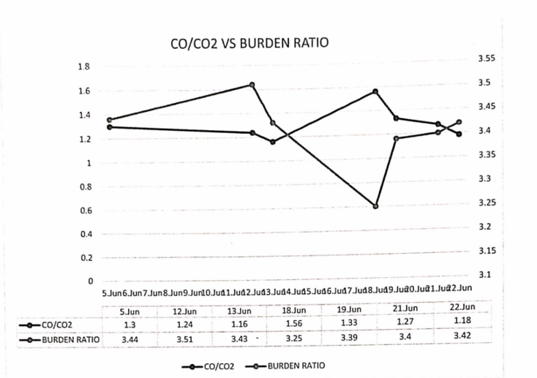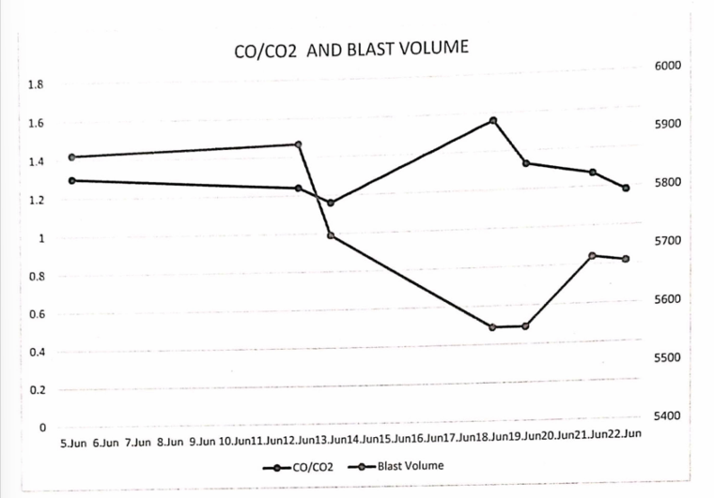

SOME IMPORTANT BF PARAMETERS:

|  |  |  |  |  |  |  |  |  |  |  |  |  |  |  |  |  |  |  |  |
| --- | --- | --- | --- | --- | --- | --- | --- | --- | --- | --- | --- | --- | --- | --- | --- | --- | --- | --- | --- |
| DATE | 05/06 | | 12/06 | | | | 13/06 | | 18/06 | 19/06 | | | 21/06 | | | | 22/06 | |  |
| BLAST  VOLUME  M3/min | 5874 | | 5889 | | | | 5730 | | 5563 | 5563 | | | 5680 | | | | 5672 | |
| BLAST PRESSURE Kg/cm2 | 3.70 | | 3.65 | | | | 3.65 | | 3.70 | 3.70 | | | 3.70 | | | | 3.70 | |
| TOP PRESSURE Kg/cm2 | 2.10 | | 2.10 | | | | 2.10 | | 2.10 | 2.10 | | | 2.10 | | | | 2.10 | |
| PRESSURE DIFF.  Kg/ cm2 | 1.60 | | 1.55 | | | | 1.55 | | 1.60 | 1.60 | | | 1.60 | | | | 1.60 | |
| BLAST TEMP. °C |  | 1050 |  | 1050 |  | 1050 | |  | 1050 | | 1050 |  | | | 1050 |  | 1050 | |
| STEAM t/hr | 5 | | 6.50 | | 5 | | | | 6 | | 6 | |  | 5 | | |  | 6 |
| % 02  ENRICHMENT | 4.30 | | 4.40 | | 4 | | | | 3.30 | | 4.20 | |  | 4.60 | | |  | 4.60 |
| OXYGEN FLOW m3/hr | 20000 | | 21000 | | 19000 | | | | 16000 | | 20000 | |  | 21000 | | |  | 21000 |

7. CONCLUSION

The productivity of a blast furnace plays a crucial role in iron making, impacting the efficiency and profitability of the entire process. Several key factors influence the productivity of a blast furnace, including raw material quality, operating parameters, and technological advancements.

Firstly, the quality of raw materials, such as iron ore, coke, and fluxes, significantly affects the furnace's productivity. Higher-grade iron ore with a higher iron content allows for increased production rates and reduced energy consumption. Similarly, the quality and composition of coke impact the furnace's performance, as it provides the necessary carbon and heat for iron reduction.

Secondly, optimizing operating parameters is essential for maximizing blast furnace productivity. Parameters such as blast volume, temperature, and oxygen enrichment need careful control to achieve the desired productivity. Balancing these parameters ensures efficient combustion and iron reduction, leading to higher production rates and improved fuel efficiency.

Lastly, technological advancements have played a vital role in enhancing blast furnace productivity. Modern blast furnaces employ state-of-the-art automation, process control systems, and advanced refractory materials. These innovations enable better temperature control, reduced heat losses, and improved iron yield, ultimately increasing overall productivity.

Overall, maximizing the productivity of blast furnaces in iron making involves a combination of factors, including raw materials.

**REFERENCES:**

[1] Ghosh, A., & Chatterjee, A. (2008). Ironmaking and Steelmaking: Theory and Practice. Prentice Hall of India.

[2] Biswas, A. K. (1992). Principles of Blast Furnace Iron Making. SBA Publications.

[3] Sarma, J., & Mehrotra, S. P. (2014). Raw material preparation for iron and steelmaking: A review. Minerals & Metallurgical Processing, 31(3), 155–166. https://doi.org/10.1007/s40553-014-0035-7

[4] Zhou, H., Zhang, L., & Shen, Y. (2019). Effect of burden distribution on the performance of blast furnace. Ironmaking & Steelmaking, 46(6), 527–536. https://doi.org/10.1080/03019233.2018.1529995

[5] Babich, A., Senk, D., & Gudenau, H. W. (2008). Ironmaking. Stahl und Eisen, 128(7), 59–68.

[6] Indian Bureau of Mines (IBM). (2022). Indian Minerals Yearbook 2022 – Iron Ore. Ministry of Mines, Government of India. <https://ibm.gov.in/>

[7] Rashtriya Ispat Nigam Limited (RINL). (2023). Annual Report 2022–2023. https://www.vizagsteel.com/code/AnnualReport.asp

[8] Steelonthenet. (n.d.). The Blast Furnace Ironmaking Process. Retrieved June

16, 2025, from https://www.steelonthenet.com/uk/bf.html

[9] World Steel Association. (2023). Steel Statistical Yearbook 2023. https://worldsteel.org/publications/bookshop/steel-statistical-yearbook-2023/